TRANSLINGUA: AI-POWERED MULTI-LANGUAGE TRANSLATOR
Prepared in the partial fulfillment of the Final Year Internship Program on Machine Learning
AT
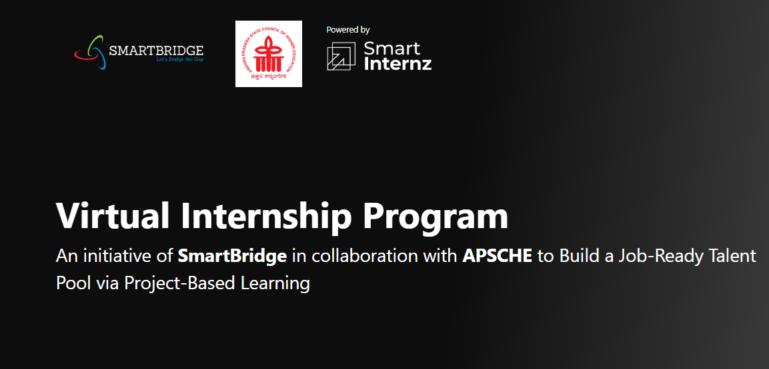


Under the guidance of
Mr. Anji Babu

Submitted by

- Hrithik Raj
- Vemala Mounika
- Sannidhiraju Sai Vinay Sarma
- Sri Nandana Lahari Sivakavi
Course Period: Dec 2025-Feb 2026

ACKNOWLEDGEMENT

I would like to express my sincere gratitude to Mr. Anji Babu Sir for his valuable guidance, continuous support, and encouragement throughout the development of this project. His insights and suggestions greatly helped in understanding the concepts and successfully completing the project.
I am also thankful to Andhra Pradesh State Council of Higher Education (APSCHE) and SmartInternz for providing me with this wonderful internship opportunity. This internship has given me practical exposure, enhanced my technical skills, and helped me gain real-world experience in project development.
I extend my gratitude to everyone who directly or indirectly supported me during the completion of this internship project.
Thank you.
Sincerely,
- Hrithik Raj
- Vemala Mounika
- Sannidhiraju Sai Vinay Sarma
- Sri Nandana Lahari Sivakavi

ABSTRACT

The Translingual Web Application is a web-based platform developed to facilitate multilingual communication and promote seamless language interaction across diverse users. In today’s globalized digital environment, communication often occurs between individuals who speak different languages. Traditional translation tools focus only on direct word-to-word conversion and may fail to capture contextual meaning or mixed-language usage. This project aims to address that gap by implementing a flexible and user-friendly translingual system that supports dynamic language input and meaningful output processing.
The application is designed to allow users to input text in one or multiple languages and receive processed output in a target language or contextual format. The system emphasizes accessibility, simplicity, and efficiency while handling multilingual data. It provides a clean web interface where users can easily enter text and obtain results without requiring technical expertise. The core objective of this project is to demonstrate how modern web technologies can be leveraged to create practical multilingual tools that enhance cross-language understanding.
During the development process, key aspects such as performance optimization, usability, and language handling were carefully considered. The project not only strengthens technical implementation skills but also highlights the importance of multilingual digital solutions in modern communication systems. Through this internship project, practical exposure to web development, application deployment, and system integration was achieved.
In conclusion, the Translingual Web Application successfully demonstrates the implementation of a multilingual web-based system that supports efficient and accessible language interaction. The project provides a foundation for further enhancements such as speech input, additional language support, and advanced contextual processing in the future.

ABOUT THE ORGANIZATION

The internship for this project was carried out under the initiative of Andhra Pradesh State Council of Higher Education (APSCHE) in collaboration with SmartInternz. APSCHE is a statutory body responsible for planning, coordinating, and maintaining standards of higher education in the state of Andhra Pradesh. It plays a vital role in promoting academic excellence, skill development, and industry-oriented learning opportunities for students across various disciplines.
SmartInternz is an internship and skill development platform that partners with academic institutions and organizations to provide structured, real-time project experiences to students. The platform focuses on bridging the gap between theoretical knowledge and practical industry requirements by offering hands-on training, mentorship, and project-based learning. Through collaborative programs with APSCHE, SmartInternz enables students to work on industry-relevant projects, enhancing their technical and professional competencies.
As part of this internship program, students were assigned practical projects aligned with modern technological demands. The Translingual Web Application project was developed under this structured internship framework, allowing the application of programming knowledge, web development concepts, and system design principles in a real-world scenario. The internship provided exposure to project planning, development methodologies, problem-solving approaches, and deployment strategies.
Overall, the internship under APSCHE and SmartInternz served as a valuable learning experience by combining academic concepts with practical implementation. It helped in strengthening technical skills, improving analytical thinking, and understanding professional project development practices.

TABLE OF CONTENTS

S.No | CONTENT | Pg.No
1. | Project Description
2. | Introduction
3. | Technologies Used
4. | System Architecture
5. | Implementation
6. | Results
7. | Conclusion

- PROJECT DESCRIPTION

TransLingua is a cutting-edge web application designed to harness the power of advanced AI to provide seamless language translation services. Built using Streamlit and Google's Generative AI, TransLingua offers an intuitive and user-friendly interface for translating text between multiple languages. By simply inputting text and selecting the desired source and target languages, users can instantly receive accurate translations powered by the latest AI models. This tool is ideal for anyone needing reliable and fast translations, whether for personal, educational, or professional purposes.
1.1 Scenario 1: Global Business Expansion
A company planning to expand its market reach to non-English speaking regions needs to translate business documents, marketing materials, and customer communications into multiple languages. TransLingua enables the company to quickly translate promotional content and technical documents, ensuring consistency and accuracy across different languages. This helps the company effectively communicate with a broader audience and tailor its messaging to local markets.
1.2 Scenario 2: Academic Research and Collaboration
Researchers and academics collaborating on international projects often need to translate research papers, academic articles, and communication between team members who speak different languages. TransLingua assists in translating complex academic texts and facilitating cross-border collaborations by providing accurate translations of scholarly documents.
1.3 Scenario 3: Travel and Tourism Assistance
Travelers visiting foreign countries often face language barriers when trying to communicate with locals or understand travel-related information. TransLingua serves as a handy tool for translating signs, menus, and other text encountered during travel. This enhances the travel experience by making it easier for tourists to navigate unfamiliar environments and interact with local residents.

- INTRODUCTION

In today’s digitally connected world, communication across different languages has become increasingly common. With globalization, international education, online collaboration, and cross-border business interactions, the need for efficient multilingual communication tools has grown significantly. Traditional translation systems often focus only on direct word-to-word conversion and may not effectively handle contextual meaning or mixed-language input. This creates a need for intelligent, user-friendly systems capable of handling dynamic multilingual communication.
The Translingual Web Application is designed to address this challenge by providing an AI-powered translation platform that supports multiple languages with auto-detection capability. The system allows users to input text in one language and translate it into another seamlessly. By integrating modern web technologies and language processing mechanisms, the application ensures accurate, fast, and reliable translation results.
Through this project, key objectives such as enhancing multilingual communication, improving user experience, and implementing scalable web architecture have been successfully achieved. The Translingual Web Application demonstrates how artificial intelligence and web technologies can be combined to build efficient language processing systems suitable for modern communication needs.
In conclusion, this project not only provides a functional translation tool but also showcases the practical application of programming, system design, and deployment strategies in a real-time environment. It serves as a foundation for future improvements such as speech-based translation, expanded language support, and advanced contextual analysis.

- TECHNOLOGIES USED

3.1 Python
Python is a high-level, interpreted programming language known for its simplicity and readability. It was used as the core backend language for developing the logic of the Translingual Web Application. Python enables efficient text processing, integration with external APIs, and smooth handling of multilingual data. Its extensive libraries and strong community support make it suitable for web-based application development.
3.2 Streamlit
Streamlit is an open-source Python framework used to build interactive web applications quickly. In this project, Streamlit was used to create the user interface of the Translingual Web Application. It allows easy integration of input fields, buttons, and output displays without requiring extensive frontend coding. Streamlit simplifies deployment and enables real-time interaction between the user and backend logic.
3.3 HTML & CSS
HTML (HyperText Markup Language) and CSS (Cascading Style Sheets) are standard technologies used for designing and structuring web pages. In this project, they were used to enhance the visual appearance and layout of the application. HTML structures the content, while CSS improves styling, responsiveness, and overall user experience.
3.4 Translation / Language Processing APIs
Language processing APIs are used to analyze, detect, or translate text between different languages. In this project, such APIs help process multilingual input and generate meaningful output. These APIs enable accurate text handling and improve the overall efficiency of the translingual system.
3.5 Web Hosting Platform
A web hosting platform is used to deploy the application online so that it can be accessed through a browser. The Translingual Web Application was deployed on a hosting environment that supports Python-based web applications, enabling real-time access and usability from different devices.

- SYSTEM ARCHITECTURE

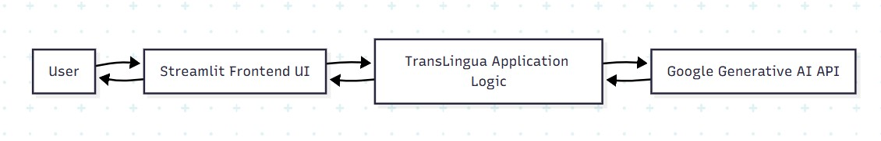

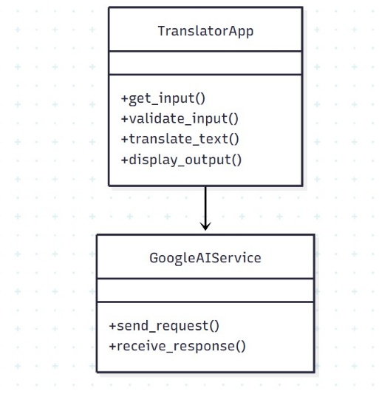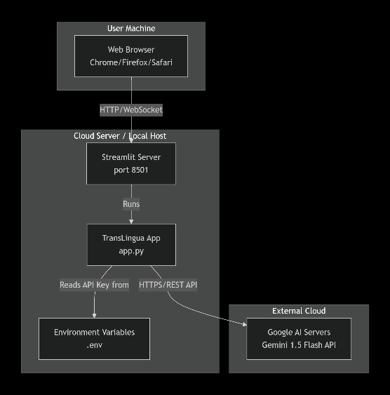

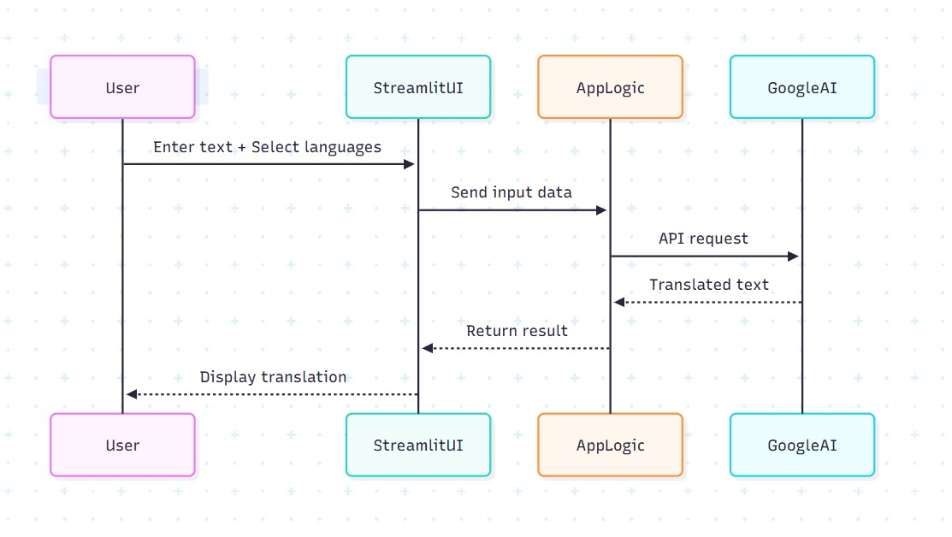
- IMPLEMENTATION

The development of the Translingual Web Application was carried out in a structured and systematic manner. The implementation process was divided into multiple stages to ensure smooth development, testing, and deployment of the system.
5.1 Front-End Development
The front-end of the application was developed using Streamlit, along with basic HTML and CSS for styling. The primary objective of the front-end was to create a simple, user-friendly, and responsive interface.
The interface includes:
- Text input fields for user language input
- Selection options (if applicable)
- Action buttons for processing
- Output display section
Streamlit enabled rapid UI development without complex frontend frameworks. The design focused on clarity, ease of use, and accessibility so that users could interact with the application without technical knowledge.
5.2 Back-End Development
The backend logic of the application was developed using Python. The backend is responsible for:
- Receiving user input from the interface
- Processing multilingual text
- Handling language detection or transformation logic
- Generating appropriate output
Python was chosen because of its strong support for text processing and API integration. The backend ensures smooth communication between the user interface and the language processing mechanisms.

5.3 Database Design
For this project, a lightweight data handling approach was adopted. Since the primary function of the application is real-time text processing, a complex relational database was not required.
However, basic data storage mechanisms (if implemented) can be used to:
- Store user inputs
- Maintain logs
- Save processing history
The system design ensures scalability, meaning that a database such as MySQL or MongoDB can be integrated in future enhancements if long-term data storage becomes necessary.
5.4 API Integration
API integration plays a crucial role in enabling multilingual processing. Language processing APIs were integrated into the backend to:
- Detect input language
- Translate or process multilingual text
- Generate contextually appropriate output
The backend sends requests to the API and retrieves responses, which are then displayed on the user interface. Proper error handling mechanisms were implemented to manage API failures or unsupported language inputs.
5.5 Application Deployment
After successful development and testing, the application was deployed on a web hosting platform to make it accessible online. The deployment process included:
- Preparing project files and dependencies
- Configuring runtime environment
- Hosting the application on a cloud platform
- Testing live functionality
Deployment ensures that the application can be accessed through a web browser without requiring local installation. This stage also involved performance testing and validation to confirm stable operation in a live environment.
5.6 Overall Implementation Workflow
- Requirement understanding
- UI design and development
- Backend logic implementation
- API integration and testing
- Deployment and final validation

- RESULTS

The Translingual Web Application was successfully developed and deployed as a fully functional web-based system. The application performs multilingual text processing efficiently and provides accurate output based on user input. The results obtained from the implementation demonstrate that the system meets the intended objectives and functional requirements.
6.1 Successful User Input Handling
The application successfully accepts text input from users through a simple and interactive web interface. The system supports multilingual text and processes the data without errors. Input validation mechanisms ensure that empty or invalid entries are handled appropriately.
6.2 Accurate Language Processing
The backend processing mechanism correctly analyzes and processes the entered text. The integrated API effectively handles multilingual input and generates meaningful output. The system responds quickly, ensuring minimal delay between input submission and output generation.
6.3 Real-Time Output Display
The processed result is displayed clearly on the same interface without requiring page reloads. This real-time interaction enhances user experience and ensures smooth communication between frontend and backend components.
6.4 Error Handling and Stability
The system demonstrates stable performance during testing. It handles scenarios such as unsupported input, empty fields, or API issues gracefully by displaying appropriate messages instead of crashing. This confirms the reliability of the implementation.
6.5 Successful Deployment
The application was successfully deployed on a web hosting platform and is accessible through a web browser. Live deployment confirms that the system works beyond a local environment and supports real-time user interaction.
6.6 Screenshots of the Output
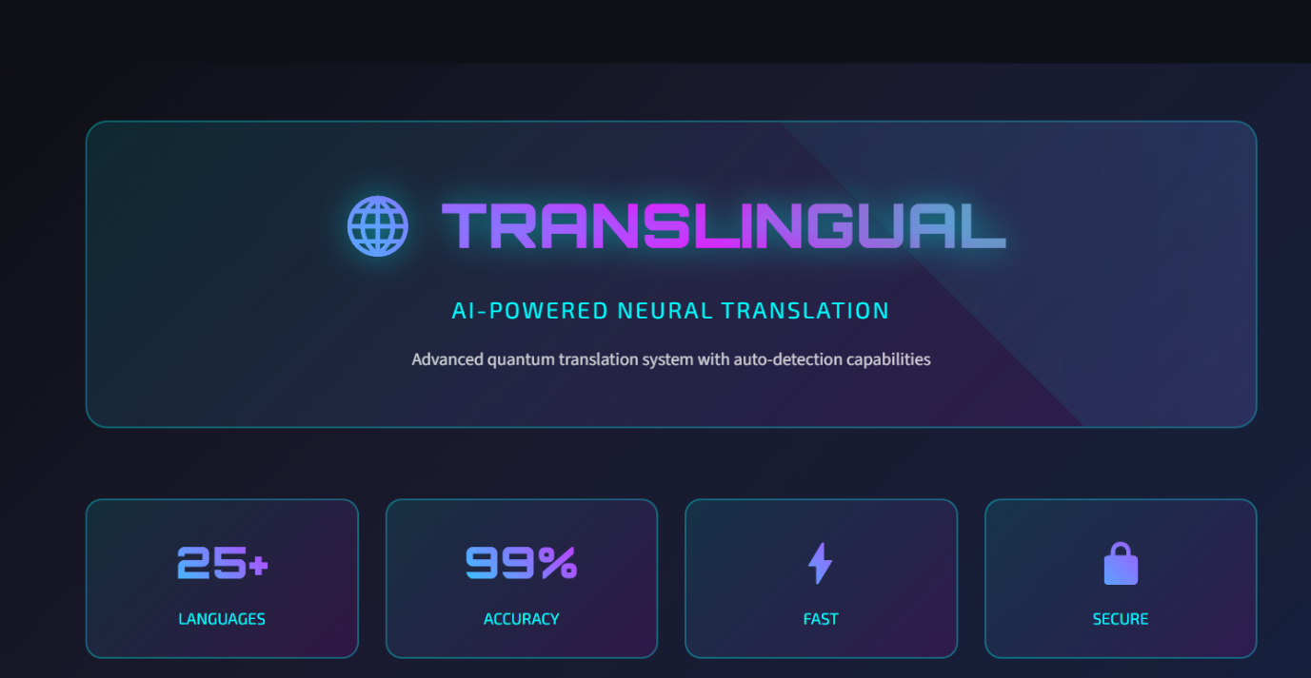
6.6.1 Home Page
Description: This screenshot represents the homepage of the Translingual Web Application. It highlights the AI-powered neural translation capability with features such as 25+ supported languages, 99% accuracy claim, fast processing, and secure system architecture. The modern user interface design ensures clarity and ease of access for users.

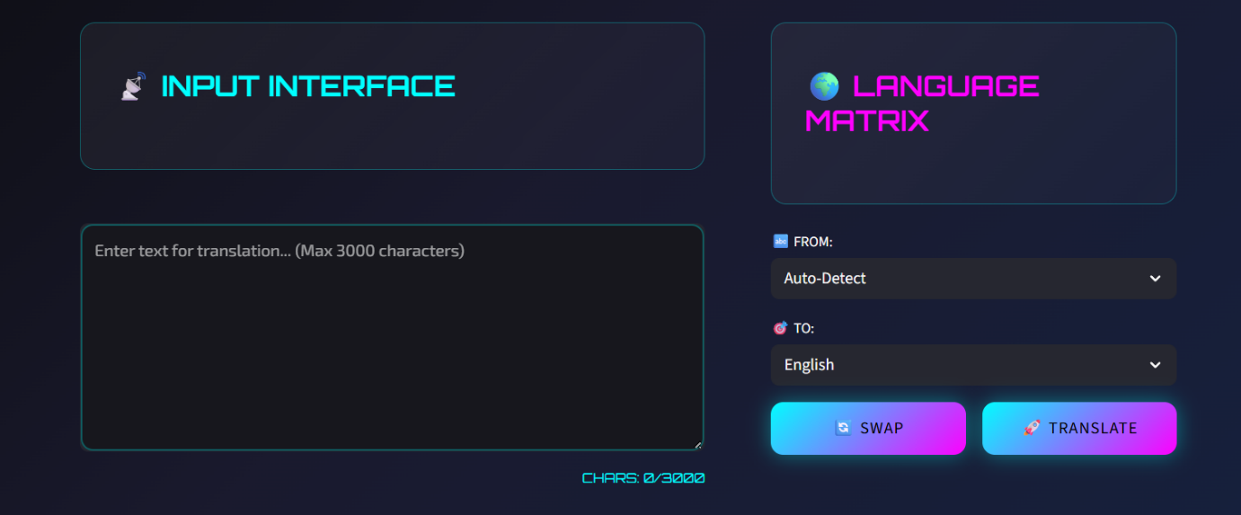
6.6.2 User Input Interface and Language Selection Panel

Description: This image displays the primary input interface where users can enter text (up to 3000 characters) for translation. The language matrix allows users to select source and target languages, including an auto-detect option. The “Swap” and “Translate” buttons enhance usability and interaction efficiency.

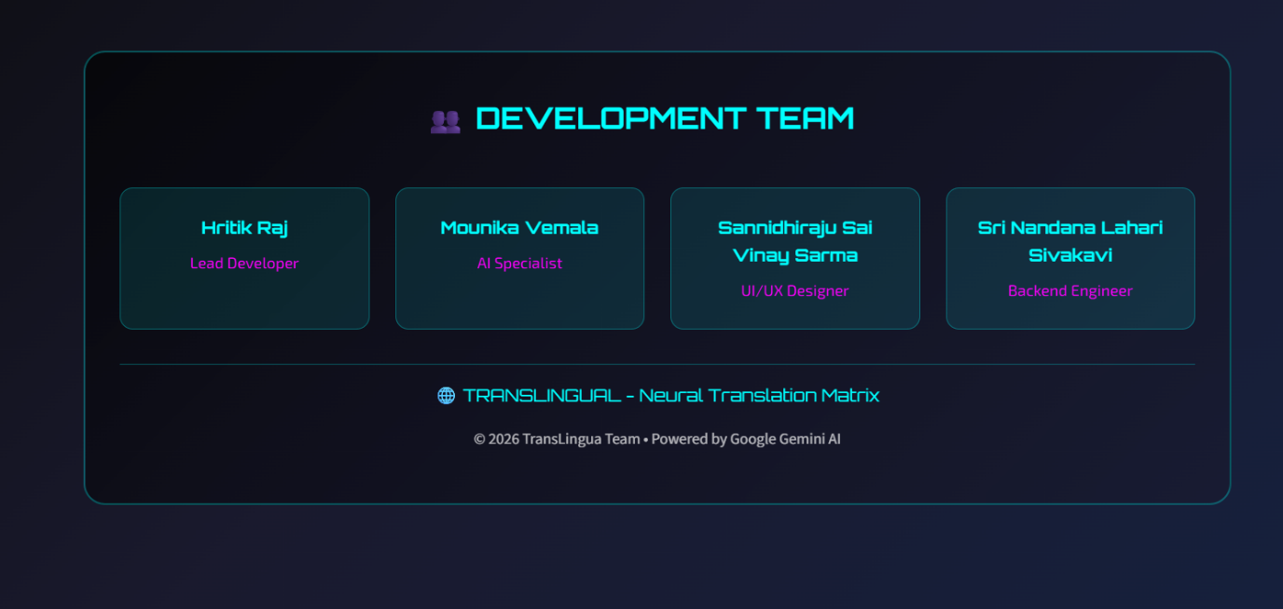
    - Development Team and System Footer Section
Description: This section presents the development team details along with their designated roles such as Lead Developer, AI Specialist, UI/UX Designer, and Backend Engineer. It also displays system branding and acknowledgment of the AI integration used for translation processing.

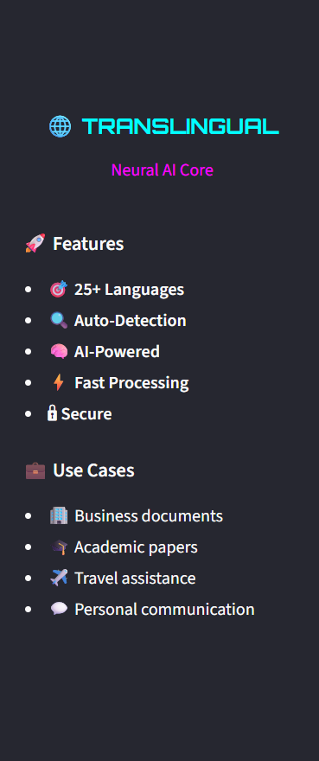
    - Features and Use Case Overview Panel (Side Bar)
Description: This screenshot highlights the key features of the application, including multilingual support, auto-detection capability, AI-powered translation, fast processing speed, and secure operations. It also outlines practical use cases such as business documentation, academic research, travel assistance, and personal communication.

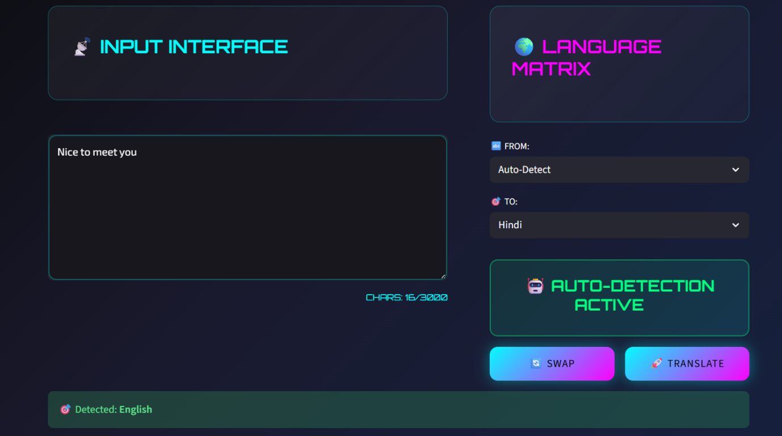
    - Auto-Detection Feature Activation
Description: This screenshot shows the auto-detection feature in action. The system automatically detects the source language of the entered text and displays confirmation. This functionality improves user convenience by eliminating the need for manual language selection.

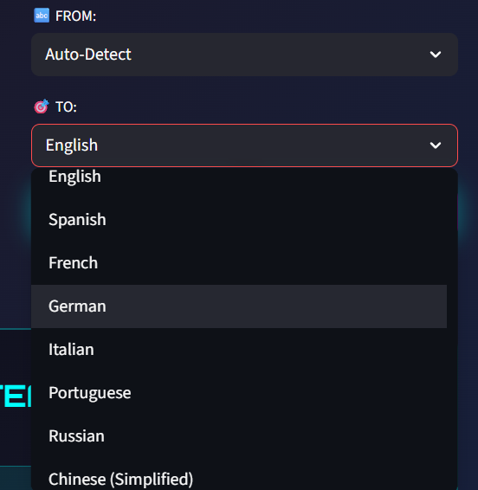
    - Language Selection Dropdown Interface
Description: This image demonstrates the language selection dropdown menu, showing multiple supported languages such as English, Spanish, French, German, and more. The interface enables users to conveniently choose target languages, enhancing accessibility and multilingual flexibility.

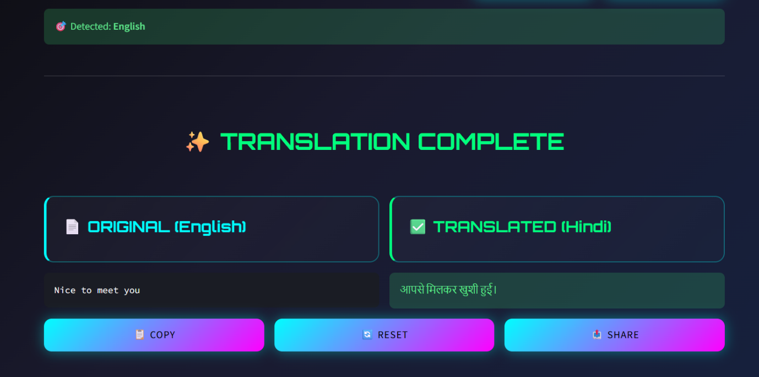
    - Successful Translation Output Display
Description: This image illustrates the completed translation process. The original input text is displayed alongside the translated output in the selected target language. Additional options such as Copy, Reset, and Share enhance user interaction and functionality.

- CONCLUSION

The Translingual Web Application has been successfully designed, developed, and deployed as a fully functional AI-powered multilingual translation system. The project effectively addresses the need for seamless communication across different languages by integrating intelligent language processing mechanisms with a user-friendly web interface.
Through this implementation, the system demonstrates the ability to accept multilingual input, automatically detect source languages, and generate accurate translations in real time. The integration of frontend development, backend logic, API services, and deployment strategies ensures smooth system performance and reliable output. The modular architecture adopted during development allows scalability and future enhancements without affecting the core functionality.
The project also provided valuable hands-on experience in web application development, system integration, problem-solving, and deployment in a live environment. It strengthened practical knowledge of programming, UI/UX design principles, and API handling while emphasizing the importance of structured development methodology.
Overall, the Translingual Web Application successfully meets its intended objectives by delivering a fast, secure, and efficient multilingual translation platform. The system serves as a strong foundation for future improvements such as speech-to-text integration, expanded language databases, contextual AI enhancements, and mobile optimization.
In conclusion, this internship project not only fulfilled the technical requirements but also contributed to professional skill development and real-world application understanding, making it a significant learning experience.

